**Ideation Phase**

**Brainstorm & Idea Prioritization Template**

|  |  |
| --- | --- |
| Date | 20 September 2022 |
| Team ID | PNT2022TMID51917 |
| Project Name | Personal Expense Tracker |
| Maximum Marks | 4 Marks |

**Brainstorm & Idea Prioritization Template:**

Brainstorming provides a free and open environment that encourages everyone within a team to participate in the creative thinking process that leads to problem solving. Prioritizing volume over value, out-of-the-box ideas are welcome and built upon, and all participants are encouraged to collaborate, helping each other develop a rich number of creative solutions.

**Step-1: Team Gathering, Collaboration and Select the Problem Statement**

**Team Gathering:**

|  |  |
| --- | --- |
| **Team Members** | |
| Team Leader | Aneesh R A |
| Team Members | Ezhil Arasu |
| Adhithyan C P |
| Suthish Kumar S |

**Problem Statement:**

I am Aneesh and I am a business man and my daily life involves spending of lot of money of various product and commodities. So I find it difficult to keep track on where my money is spend most and want to limit my spending habit by knowing where I spend it most .

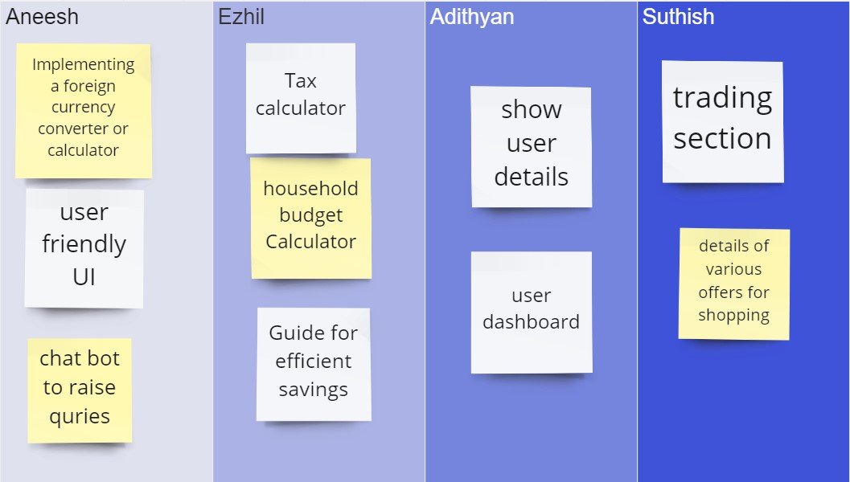**Step-2: Brainstorm**

**Step-3: Idea Prioritization**

